* **Lab Task 4**

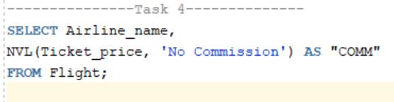Display the Airline Name and a placeholder for commission. Since we do not have commission data in the Flight table, we will simulate that.

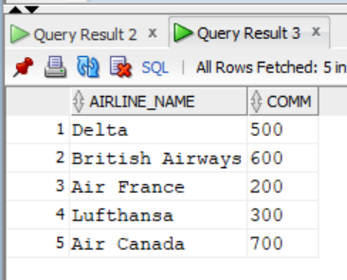

Output: